CHAPTER 16
SOUND AND HEARING
Discussion Questions
Q16.1 The frequency is the number of cycles per second and doesn’t change. The number of cycles arriving per unit time at one side of the interface between the two materials must equal the number leaving the interface on the other side in the same time. The wave speed increases so by 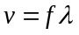 the wavelength must increase.

Q16.2 Compression waves in the metal rails travel faster than sound waves in the air.

Q16.3 The wave speed increases with temperature, so by Eq.(16.18) and (16.22) the pitch increases with temperature.

Q16.4 Different notes correspond to different standing wave patterns in the air columns inside the instrument, to overtones with differing number of nodes. The lowest possible note corresponds to the frequency of the fundamental, but there is no physics limit on the highest note. But higher overtones may be difficult to produce. All the notes must have a frequency that is an integer multiple of the fundamental frequency.

Q16.5 This brings the instrument and the air inside to the same steady-state temperature it will have during the performance. The speed of sound depends on the air temperature, so the pitch of the note is affected by temperature.

Q16.6 The speed of sound in helium is much higher than in air so the standing waves in your vocal track have higher frequency when the vocal track is filled with helium rather than air.

Q16.7 The tires vibrate at the frequency at which the ridges are encountered. This frequency is proportional to the speed of the car.

Q16.8 (a) No. The sound intensity level is given by 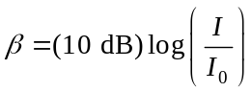. 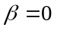 means 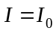, since 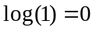. When there is sound, with intensity equal to the reference intensity 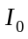. (b) Yes. The sound intensity level 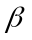 is negative when the intensity is less than the reference intensity . (c) Yes, a sound intensity of 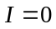 means there is no sound. (d) No, the sound intensity cannot be negative.

Q16.9 The eardrum is set into vibration by pressure variations so the pressure amplitude has the most direct influence. But, these two amplitudes at a given wavelength or frequency are directly proportional to each other (Eq.16.5).

Q16.10 According to Eq.(16.14), the intensity is proportional to the square of the pressure amplitude. If 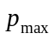 is halved, decreases by a factor of 4. If the pressure amplitude is increased by a factor of 4, the intensity will increase by a factor of 16.

Q16.11 No. The sound intensity level is given by 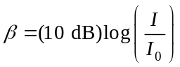. If obeyed the inverse-square law, doubling r would change the sound intensity level from to 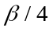. That is, if at a distance r the sound intensity level is 60 dB, at distance 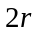 the sound intensity level would be 15 dB. But Example 16.9 shows that doubling the distance from the source decreases by 6.0 dB. That is, if at distance r the sound intensity level is 60 dB, then at distance the sound intensity level is 54 dB.

Q16.12 The inverse square relationship is Eq.(15.26). If 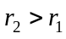, the absorption of energy means that 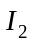 is less than 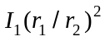; the intensity falls off faster than 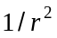.

Q16.13 The added mass slows the vibration of the tine and therefore decreases f. The sound wave in air has the same frequency as the tine and for the sound wave in air 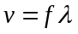. So, the frequency of the sound wave decreases and its wavelength increases.

Q16.14 The sound wave reflects from the walls and continues to propagate inside the building. The sound energy is converted to thermal energy due to dissipative forces in the air and during the reflections.

Q16.15 The interference is constructive if the path difference is an integer number of wavelengths. It is destructive if the path difference is a half-integer number of wavelengths. For this source, 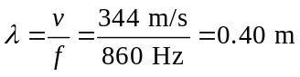. The path difference is 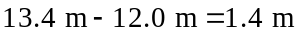. 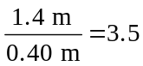. The path difference equals 3.5 wavelengths and the interference is destructive.

Q16.16 The observed frequency of the rotating fork is shifted by the Doppler effect. Its pitch is increased when it is moving toward the listener and is decreased when it is moving away from the listener. The listener therefore hears two different frequencies from the two forks and beats occur.

Q16.17 The person is moving toward one source and its pitch is raised and is moving away from the other source and its pitch is lowered. When the two parts of the organ sound the same note the moving listener hears two different pitches.
Q16.18 In Eq.(16.29) the velocities of the listener and source are relative to the medium in which the wave is traveling. In this case this is the air. The direction from the listener to the source is positive. If the wind speed is 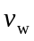, then 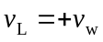 and 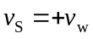. The factor multiplying 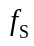 in Eq.(16.29) is unity and there is no shift in frequency; 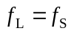.

Q16.19 Boats moving on the surface of the water will observe a Doppler effect for the surface waves. The listener can be in one boat and the other boat can be the source of the waves. For elastic waves propagating below the surface, a Doppler effect will be observed for sources and listeners moving beneath the surface. One example is two submarines, where one produces the elastic waves and the other contains the listener, that detects these waves.

Q16.20 One edge of the star is rotating away from us and the opposite side is rotating toward us. Therefore, the light from the rim of the star at its equator is Doppler shifted and the measured frequency shift can be used to measure the tangential speed v at the equator.

Q16.21 What determines the Doppler shift is the component of the train’s velocity component along the line between you and the train. This component steadily decreases as the train approaches, is zero as the train passes, and then starts to increase in the opposite direction.

Q16.22 In case 1, the frequency the observer hears is 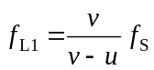, where is the speed of the source and v is the speed of sound in air. In case 2, the frequency the observer hears is 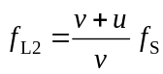, where now is the speed of the observer and has the same numerical value as for case 1. 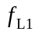 is not equal to 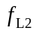. The motion of the source affects the wavelength of the observed sound and the motion of the observer affects the speed at which the waves pass the listener. The Doppler shift equation involves the velocity of the observer and the velocity of the source separately, not the relative velocity between the observer and source. The difference between the frequencies for the two cases in this question is 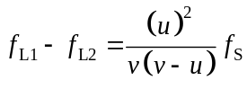, The frequency for case 1 is larger than for case 2. But if then the difference in frequencies is very small. For a numerical example, let 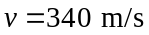 and 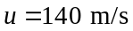. Then 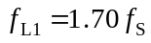 and 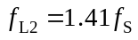.

Q16.23 No, the aircraft continually produces a shock wave as it travels at a speed greater than the speed of sound in the air. An observer on the ground hears the “sonic boom” when this shock wave passes over him.

Q16.24 The air inside the plane is moving with the plane, so sound travels relative to you within the plane with the speed of sound just as it does when the plane is at rest. You don’t hear any effect of the shock wave. The sonic boom results from the rapid jump in air pressure when the shock wave passes an observer. The shock wave travels with you so the pressure at your location remains constant.
Q16.25 A sonic boom results from the rapid change in pressure as the edge of the shock wave passes by. A person at B hears a sonic boom; observers at A and C don’t.

